
Cap ‘M’ Audio NorBit
Engineered to elevate your audio experience, the NorBit delivers clarity, precision, and purity to digital-to-analog conversion, ensuring superior audio quality.

Introducing the NorBit with TTCES: Revolutionizing Ethernet Audio
At Cap 'M' Audio, we are thrilled to unveil the NorBit, featuring our groundbreaking TTCES (TrueToneControl Ethernet Signal) technology. If you’ve ever struggled with inconsistent sound quality in high-end audio systems when connected to an Ethernet network, you’re not alone. Even the most advanced systems are susceptible to changes in the Ethernet setup.
1. NorBit inside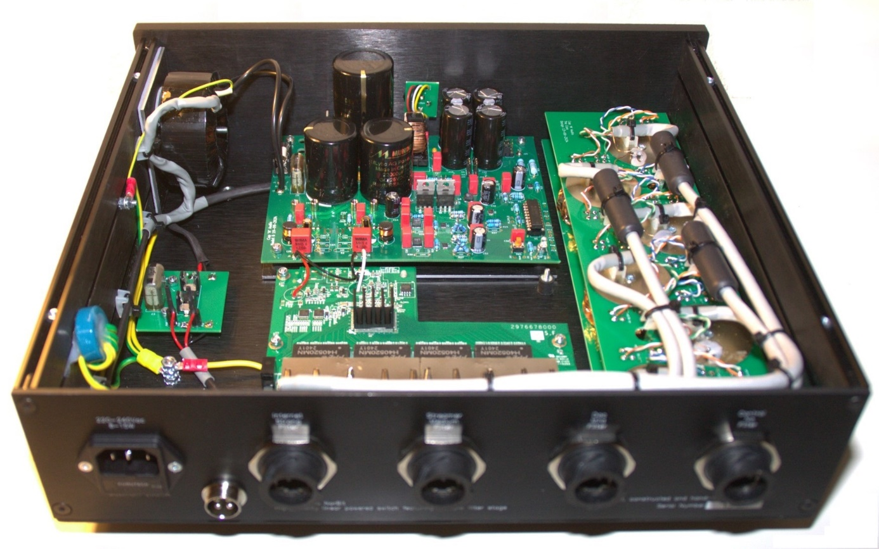
Let’s rethink everything we know about Ethernet. Forget about ones and zeros, noise, jitter, or premium cables. Instead, consider Ethernet as what it truly is: an analog signal. While we interpret Ethernet as digital, it’s fundamentally analog. Each bit (zero or one) is created with a voltage over time (it’s not a One or Zero), influenced by factors like rise time, shape, fall time, and saturation. These nuances are what your DAC interprets as digital information—and the better the bit’s shape, the better the sound. Noise certainly plays a role, but it’s crucial to understand its impact on the bit’s shape and how that translates into sound quality.

How TTCES Transforms Your Audio Experience
TTCES is seamlessly integrated into the Cap 'M' Audio NorBit and Switch, providing unprecedented control over Ethernet signals for audio. Once installed, you’ll notice a dramatic improvement in sound quality—even if you’ve already optimized your network. Expect a more natural sound, a deeply insightful soundstage, and a strikingly quiet background. Over the first 24 hours, the quality will continue to refine itself as the system settles in.
What truly sets TTCES apart is the ability to fine-tune the bit shape to your preferences and network requirements. This precision control empowers you to achieve unparalleled sound quality tailored to your unique setup.

Integrated Powersupply
A critical component in crafting a high-quality Ethernet signal is the power supply. For the NorBit, we employ four ultra-low-noise voltage regulators as a stable reference, eschewing traditional feedback control entirely. By relying solely on these reference regulators, our power supply achieves exceptional performance, ensuring the NorBit stands out in delivering uncompromising audio quality due to the precisely shaped ethernet signal.

Tripple filter stage
The NorBit incorporates a sophisticated triple-filter section, precisely optimized to reduce noise for each type of port. The Internet port features a strong filtering section, the Streamer port benefits from a medium filter, and the DAC port uses a more relaxed, mild filter for less aggressive noise reduction. This tailored system enhances noise suppression for each specific use case. Utilizing a combination of ferrite and metal powder cores, the filters gradually smooth the signal, resulting in a cleaner and more accurate output at every stage. After extensive testing with a wide range of components, we developed an optimal filtering solution for each port type. This advanced filtering system, together with the integrated Cap ‘M’ Audio power section, ensures that the NorBit delivers superior performance for all your streaming needs.
2. NorBit 10mm Frontpanel
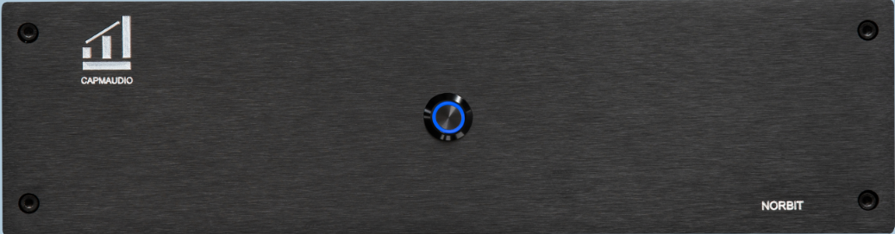
3. NorBit backside
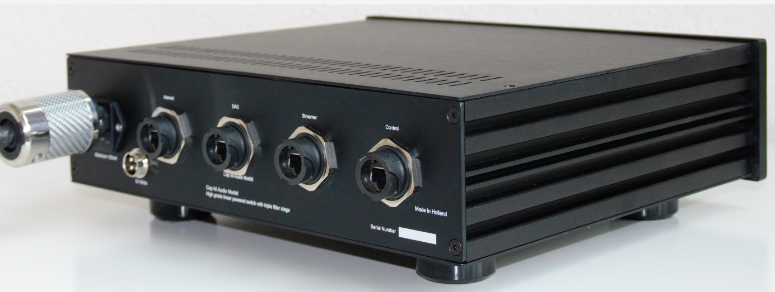

Please take a look at our website and our products at Cap'M'audio. In the next few weeks we will introduce product prices and newer pictures of our products. Also take a look at the reviews which are based on the NorBit without the latest features.

